Questions Part 1

**1. Plan out a testing strategy (how you will verify the requirements in this doc have been**

**fulfilled) and write a test plan based on it**

* Test-Strategy and Test-Plan are attached to this E-mail.

**2. Write the use cases for following machine and bonus features:**

**a. Machine - Lava Link**

**b. Bonus - Basic Spin**

* Use cases are attached to this E-mail.

**3. Write the bug report, in addition to the usual contents of a bug report, for each bug add**

**an assignee from this list:**

**a. Developer**

**b. Animator**

**c. UI/UX Designer**

**d. Other (if you think the ones listed above don’t apply to the bug)**

* Bugs are reported in Jira: <https://aleksa.atlassian.net/jira/software/projects/PS/boards/4>

**4. What would you change/implement in the machine design or functionality as an**

**Improvement?**

* In my opinion I woud make MPF larger, maybe even show less players sitting on machines on the left. Or make the pay-multi auto-bet buttons larger, because some users may have smaller screens and difficulties clicking them.
* The game might be even more interesting if it was possible for each player sitting on machine to choose and play 1 reel only, and to share the prize with others who also play 1 reel-game.

**5. What type of testing would you be performing to test the machine as a whole?**

* Integration testing

**6. In a scenario where the machine is finalised and stable, you receive a small change that**

**applies to only one feature of the machine and you’re supposed to test only that feature,**

**what type of testing would you be performing?**

* New Feature Testing

Questions Part 2

**7. If we have a sale pop up with 2 buttons:**

**a. one “Buy” button to take the player through the purchase process**

**b. one “X” button to give player the option to close the sale pop up**

**and the “X” button is not closing the pop up, the only clickable button is “Buy”, when you**

**open a ticket for it, what would be the bug severity and why?**

* Bug severity would be critical, because user cannot close the popup. Most of the users will not go through purchase process and would rather close popup. If they are unable to close it, the only option left for them is to close the game. This can be very irritating for users and can cause them to give up playing.

**8. You have a pop up in the app with a button that should take the player to the machine**

**but the button is taking the player to the Store instead, write a ticket for it.**

* Bug is reported in Jira: <https://aleksa.atlassian.net/browse/PS-4?atlOrigin=eyJpIjoiZGMzZDFlMzkzZWQwNDc1MzlkYWM0ZDc0OGRkNzc1MzAiLCJwIjoiaiJ9>

**9. We have a pop up that we have to release to players in the next 30 minutes, the text in**

**the pop up should say:**

**a. “The 50 players who complete the most MiniPops will win a share of 50B chips**

**prize pool.”**

**Last minute, you notice there is a mistake in the text and instead it says:**

**b. “The 50 players who complete the most MiniPops will win a share of 50B chips**

**price pool.”**

**the pop up is still expected to be released in the next 30 minutes and the process of**

**fixing it will take a bit longer, how would you move forward?**

* I would inform Team Lead or PM about the issue and act as they suggest. I would try to explain to them clearly the importance of the difference in the meaning of these two sentences. I would explain to them that users may have different expectations, feel cheated, which can cause customer dissatisfaction.

**10. In the next photos you will see 2 designer’s references for pop ups and then pop ups you**

**received for testing, list all the bugs you find for both:**

**Reference 1:**

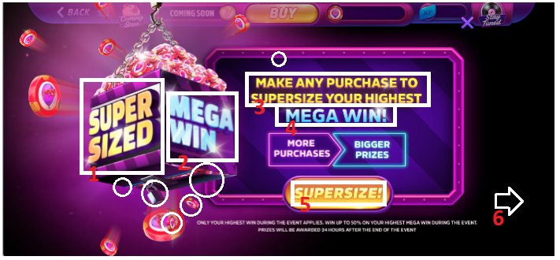1. SUPERSIZED text is in Gold color, should be Purple.

2. MEGA WIN text is in Blue color with bright spots, it should Gold color with Purple glow.

3. MAKE ANY PURCHASE TO SUPERSIZE YOUR HIGHEST text is in Gold color with bright spots, it should be white color with purple glow.

4. MEGA WIN is Blue color with bright spot, it should be gold-gradient color.

5. SUPERSIZE! Is not correct, it should be SUPERSIZE ME!, and smaller font size.

6. Background opacity should be lower; nothing can be seen except top UI.

**If popup is not animated**, then we consider circles also as a bug. Coins are not in right spots and padlock is not hanging straight.

Also, **top UI** looks different, might be due to version of the game.

**Reference 2:**

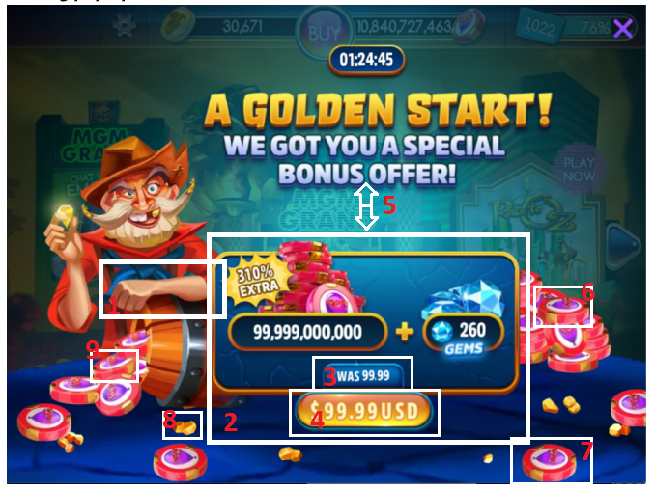1. Position of hand over barrel is not correct and its more left relative to character’s tie.

2. Box with text and prices is overall smaller.

3. “WAS 99.99” has to have $ sign before number, also on reference it is $9.99.

4. “$ 99.99 USD” is not correct. It should be less than price it was earlier and button is smaller according to the designer’s button and it should be in line with box border. I think there is also mistake in designer’s reference, where price “WAS 9.99” and new price is higher - “$99.00 USD”, which is not logical and something that should be promoted in popup.

5. Padding between upper heading and box with prices should be smaller.

6. Chip should be behind the one that leans on it.

7. Chip is not in the right spot.

8. Lump of gold looks different than in designer’s reference.

9. Chip should not be underneath the one above it.

Screen from reference and screen from testing popup are not the same size, that is why it may vary a little, also that is seen in top UI which is also different.

I am not sure if number of extra %, chips and gems are correct because they are added dynamically.